Abstract

A Social Networking website where people can create profile, post text, like or comment on post, and add or remove a friend.

Capstone

Group Project

Professor Name: Sweta Akshi

Group Members:

Karan Anand Shukla

Sohail Virani

Amandeep Kaur (2414)

**Research**

Trends in Web Development:

Progressive Web Application (PWA):

Progressive Web Applications provide ease of development and almost instant wins for the application’s overall user experience. Progressive web apps are websites that look and feel like an app. This means users can access all information and capabilities without downloading a mobile app. Instead, progressive web apps use modern web technology to deliver app-like experiences to users, right in their browsers. This type of application is gaining momentum in the development space because it can also be used offline and can sync content to multiple devices.

Single Page Application (SPA):

Single-page application (SPA) is a web application based on JavaScript which works well among user devices. It boosts performance, minimize interruptions due to page reloading and decreases web development time by responding to navigation actions without creating a request to fetch new HTML from the server side.

It’s an excellent pick when building responsive websites, support mobile, tablet & desktop apps. Most recent developments on SPA are based on React and Angular frameworks that make it practical and suitable for hybrid apps.

Accelerated Mobile Pages (AMP):

Google takes serious steps to enhance the mobile browsing experience. The company first [introduced](https://googleblog.blogspot.com/2015/10/introducing-accelerated-mobile-pages.html) Accelerated Mobile Pages Project to publicity back in 2015 and nowadays it’s one of the latest trends of web technologies.

This technology is created to encourage building websites that load instantly and work very smoothly across mobile devices. AMP pages are loaded for about 2 seconds vs. up to 22 seconds for non-AMP pages.

Below images shows the difference between a normal website and AMP:

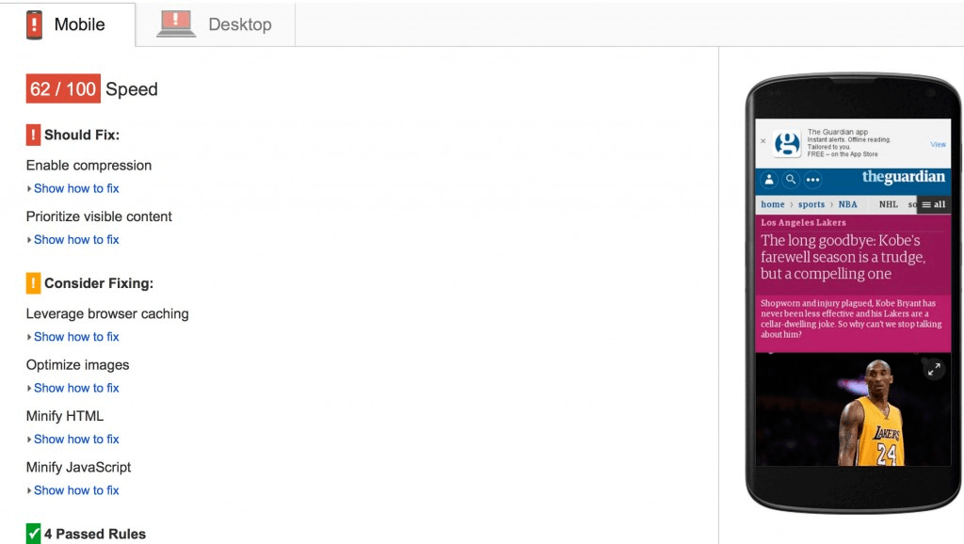

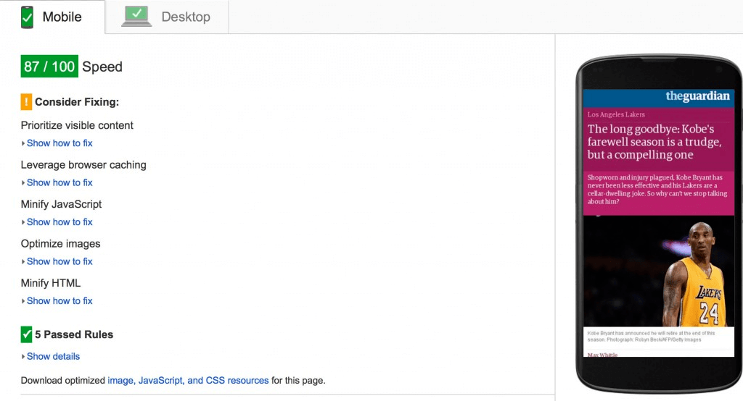

Few Buzzwords that are going around are listed below:

1. Net Neutrality: Neutrality is the concept that a government or an Internet Provider should treat all data on the internet the same way, no matter where it comes from, where it is going, or what it contains.
2. Big Data: Big Data typically refers to **a set of data so big** that traditional analysis software struggles to analyze it.
3. Data Mining: The concept of discovering patterns from large amounts of data is known as Data Mining.

Findings on web designer from job postings are as follows:

1. SCSS, SMACSS, BEM, GRUNT & GULP.
2. LAMP stack, E-commerce systems.
3. SASS\LESS

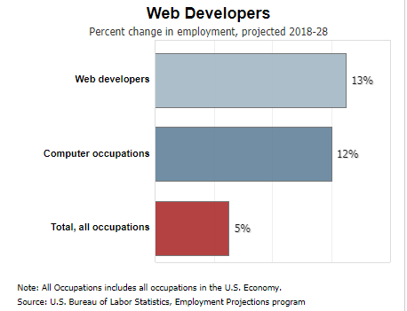

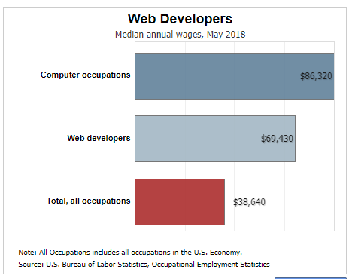

The average salary for a Web Developer is **$26.53** per hour in Canada. Salary estimates are based on 502 salaries submitted anonymously to Indeed by Web Developer employees, users, and collected from past and present job advertisements on Indeed in the past 36 months. The typical tenure for a Web Developer is less than 1 year.

The most high paying being **Data Analyst, Full Stack Developer, and Java Developer**.

**Proposal**

1. What is the key functionality of the website you want to make?

* The key functionality of our website will be to load faster than conventional websites.
* The database will be handled by a framework to ease the job of Database Administrator.

1. What content will it contain?

* The content of the website will be text, images, and other media.
* A scrapbook like social networking website.
* Features to add friend, post messages, and add profile pictures.

1. What technology will you use?

* We will use Django ORM (object-relational mapping layer) for database operations at backend for admins.
* The website will be a Single Page Application made with Rest API.
* For mobile devices we are using AMP (Accelerated Mobile Pages) framework to speed up the loading time of web pages on mobile devices.
* We are making our website as PWA (Progressive Web Application) which intents to deliver through the web, built using common web technologies including HTML, CSS and JavaScript; which can be used in any browser irrespective of device size, Operating System or hard drive size.
* An all events triggering Google analytics tag to track the activity of the website.

1. What extra functions would you add if you get more time?

* If we would get more time, we would like to add an Apache server at the backend and with AWS EC2 console (I3 and I3en instances) we would add firewalls to increase the security of database from hackers.
* Using multiple servers for faster data recovery and back-up at the time of server crashing due to high website traffic.
* Using serialization with Python to make the high volume of data structured.
* A chat feature with which users can interact with each other.
* Adding theme changing functionality, dynamic search, and font changing feature.

1. What new technology would you like to learn while you’re doing the capstone?

* Django which is a Python based framework used for object-relational mapping and serialization. So, we have to learn common commands used to install and use the framework. Also, we have to learn common expression building syntax done with python.
* PWA (Progressive Web Application) technologies.

1. How will you learn the new technology?

* There are many online resources available for us to explore. Most of which is available on LinkedIn Learning.
* For errors we can check on Stack Overflow.
* Some other references and online materials used are as follows:
* <https://ca.indeed.com/jobs?q=web%20developer&l=Kitchener%2C%20ON&vjk=4e2db49285f27a68&advn=169607626964296>
* <https://medium.com/@BennettGarner/build-your-first-rest-api-with-django-rest-framework-e394e39a482c>
* <https://devarea.com/building-a-web-app-with-angular-django-and-django-rest/#.XjMltkdKiUk>
* <https://www.django-rest-framework.org/tutorial/1-serialization/#introduction>
* <https://www.freecodecamp.org/news/using-django-with-mongodb-by-adding-just-one-line-of-code-c386a298e179/>
* <https://en.yeeply.com/blog/top-5-examples-web-app-development/>
* <https://amp.dev/documentation/guides-and-tutorials/contribute/adnetwork_integration/>
* <https://www.infoworld.com/article/3271126/what-is-cicd-continuous-integration-and-continuous-delivery-explained.html>
* <https://medium.com/@sprocompany/what-makes-an-app-to-be-a-progressive-web-application-60ddce7aafc9>
* <https://ca.indeed.com/salaries?from=gnav-acme--discovery-webapp>
* <https://www.workbc.ca/careers/2175>
* <https://www.bls.gov/ooh/computer-and-information-technology/web-developers.htm>

1. What could go wrong with your project while you develop it?

* As we are using so many technologies, there are many complications which could arise while making the project like error handling.
* There could be an incompatibility issue with so many technologies working together.
* Maintaining the timeline of all the sprints.

1. What will you do if you run into an extremely difficult problem while creating it?

* There are many ways to deal with this problem. The best way is to ask an expert, which in this case will be the professor.
* Online forums Stack Overflow, also have solutions for almost everything which will come in handy.

**Wireframe:**

**Home Page**

